SoCaLS Community Newsletter  April 2022  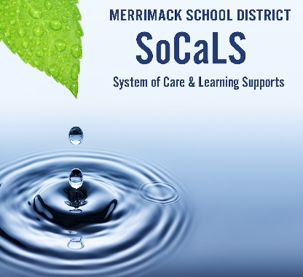  Quality Resources to Learn More  Educators:  A trove of great activities from Act for Youth to foster self-awareness!  An overview of core SEL skills with activities from Panorama.  Parents:  A comprehensive guide by age and stage for each core SEL skill!  The National Association for School Psychologists (NASP) has put together a thorough, brief guide that offers insight about how to support young people impacted by the war in Ukraine.  Upcoming Events  The calendar of Wellness events is now published on the MSD website. Click here for links to information and registration.  March-May: Brain-Based Parenting with Dr. Alison Roy  April 21st: Save the Date! Screening of LIKE Register Here: https://www.sau26.org/domain/1309  May 10th, 6:30 – Little Theater, MHS Justice John Broderick on the Youth Mental Health Crisis in NH  Saturday, May 21st: 10 AM-1 PM It Takes a Village Community Social-Emotional Wellness Fair,  Camp Sargent! More information coming soon! | Thinking about SELF-AWARENESS 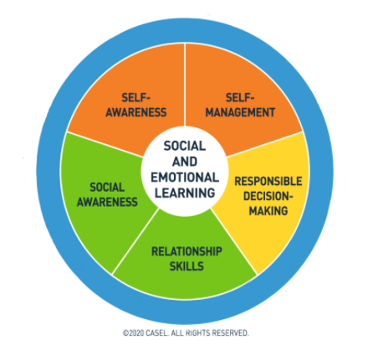  THE 5 CORE SOCIAL-EMOTIONAL LIFE SKILLS From CASEL  (Collaborative for Academic and Social-Emotional Learning)  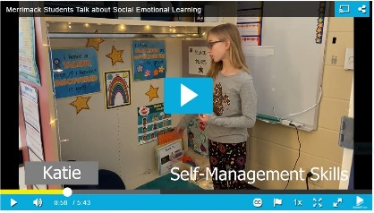  Students and teachers talk about SEL in the Merrimack School District in videos presented to the Merrimack School Board in February. Check out what self-awareness looks like!  Self-awareness unlocks the ability to manage behaviors, make decisions, discover strengths, overcome challenges, and develop confidence, and so it is a vital skill for successful learners. It is also essential for success in the workplace.  Here are three ways to cultivate self-awareness at home and at school.  - Develop a rich and specific emotional vocabulary. Use the Mood Meter or Feelings Wheel. Integrate these tools in daily routines, before and after the introduction of new concepts or activities, or to prompt discussion about the day.  - We can learn about learning, recognizing that our brains grow with “productive struggle.” Post the word, “YET” in classrooms and at home to remember that learning takes practice and time. “I can’t do this…YET.” We can “fail forward” by celebrating mistakes as opportunities to develop strengths.  - We can listen empathically, helping young people feel seen and understood, developing self-awareness through the experience of a trusting relationship. (The link above offers great “empathy” sentence starters.)

